Funded Early Education at Curious Learners Childcare
We accept a range of Government funding options to support families with early years childcare costs. This includes the 30 hours funded childcare for eligible working families, the universal 15 hours funding for 3-year-olds, and the 15 hours funding for eligible 2-year-olds receiving additional support. Funding can be taken either as term-time only over 38 weeks of the year, or stretched across 50 weeks to provide a consistent weekly allocation. Specific funding dates, nursery Christmas closure, and bank holidays are confirmed at the start of each academic year.
If you would like your child to attend more than their funded sessions, funded hours will be applied first, and any additional hours will be charged in line with our fees stated below.
You can start using your entitlements from the term after your child turns the relevant age to use that entitlement. The relevant age for the working parent entitlement is 9 months old.
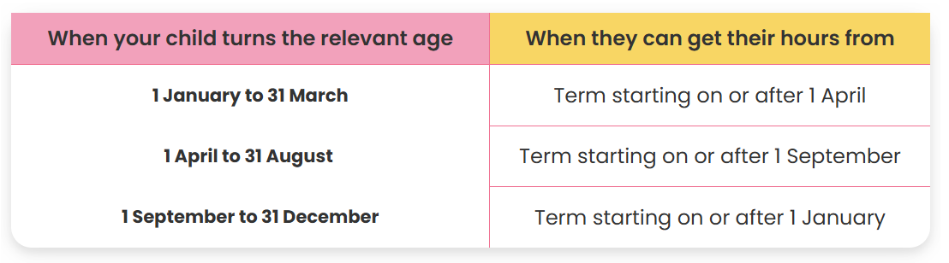

Stretched Government Funding
If you choose to stretch the funded hours over 50 weeks, the amount you receive will vary based on your child’s start date. Children starting in the Spring (January) or Summer (April) term will receive fewer hours, as government funding is provided on a pro-rata basis from when your child becomes eligible. If you child is eligible for 30 hours funding, their hours will be doubled.
Please note that we are unable to stretch funding for children starting midterm. Therefore, families who wish for their child to start midterm and want to stretch their funding will have their fees calculated accordingly.
Start Date | Remaining weeks in academic year | Funded hours per week
1st September | 50 Weeks | 11.4 hours
1st January | 33.4 Weeks | 10.77 hours
1st April | 20.8 weeks | 9.37 hours
If you would like to discuss this further, please speak to the nursery manager.

Sessions
We are proud to offer a range of flexible childcare session options for all our families at Curious Learners Childcare LTD. Our sessions are structured to make the best use of funded hours while supporting children’s routines and learning. Session options are subject to availability and are offered in line with nursery capacity and operational requirements. Our sessions are:
Full Day (10 hours) | 08:00 - 18:00
9 hr Full Day | 08:00 - 17:00 / 09:00 - 18:00
8 hr Full Day | 08:00-16:00 / 09:00-17:00
Short Day (7 hours) | 08:00-15:00 / 09:00-16:00
Morning or Afternoon Session | 08:00 - 13:00 / 13:00 - 18:00
Short Morning / Short Afternoon Session  (All week only / Term Time Only) | 08:45 – 11:45 / 13:00 – 16:00
School Day | 09:00 - 15:00

Fees
Fees are calculated based on the number of sessions your child is scheduled to attend each month and are payable in advance for the upcoming month.
Nursery fees include all sick days and holiday taken as these are paid days. Fees are based on booked days not attendance. Fees are due by the last working day of each month, for the month your child is about to attend.
Our fees are as follows:

 | Babies  (0-2 years) |  | Toddlers Room  (2-3 years) |  | Pre-School Room  (3-4 years)
 | All Year-Round | Time-time only | All Year-Round | Time-time only | All Year-Round | Time-time only
Hourly Rate | £9.00 | £10.00 | £8.50 | £9.50 | £7.50 | £8.50
Early Drop Off | Permanent booking: £6.00 |  |  | Adhoc booking: £8:00
Adhoc Hourly Rate | £12.00

Early Drop Off:
We offer early morning drop-off from 7:45am. Please speak to a member of management for more information regarding this additional service.
Deposit
Once your child has been offered a space and you have agreed sessions with the nursery manager, a deposit is required to secure your child’s place at Curious Learners Childcare. The deposit must be paid within 5 working days from your offer. If you decide not to take up the space offered and you have paid the deposit, Curious Learners Childcare LTD is not obliged to return the deposit.
If your child attends funded sessions only, a £20.00 deposit is required. This amount will be deducted from your first full month’s invoice until the full deposit has been returned to you. If your invoice totals £0, the £20.00 deposit will be refunded within four weeks of your child’s start date.
If your child is doing more then their funded sessions a £75 deposit is required. This will be held on your child’s account and refunded back to you when you decide to leave providing you have given 4 weeks notice and your account is up to date.
The deposit can not be used to pay for additional hours, late collection charges or late payment charges.
All Inclusive Enhanced Provision:
Meals | Digital Learning Platform | Consumables
8:00-18:00/ 08:00-17:00 - £8.50  09:00-17:00/09:00-18:00 - £8.00  08:00-15:00/08:00-16:00 - £7.00  09:00-15:00/09:00-16:00- £6.00  08:00-13:00 – £5.50  13:00-18:00 - £4.50  8:00-11:00 - £1.50  13:00-16:00- £0.50 | £1.00 per Funded Session  - Access to our Digital Learning Platform  - Daily Updates on your child  - Termly progress reports  - Parent Consultation  - Easy Messaging Service  - Keep up to date on Nursery news  - Paper free enrolment process  - Printed learning journey when your child leaves  - In app payments and invoices | £1.50 per funded session  - Wet Wipes  - Nappies (under 2)  - Nappy Sacks  - Sudocrem  - Suncream  - Graduation  - Christmas Parties  - Bedding (bed sheet and blanket)  - Celebration days (easter gifts, Christmas gifts)  Special events: celebration-themed crafts, food-tasting activities, baking experiences, summer picnics, Christmas activities, and additional resources to support special celebration days.  Special learning experiences such as getting caterpillars for hands-on learning and Incredible Eggs, who bring eggs and an incubator for our children to see baby chicks hatch!
Government funding covers the cost of delivering the Early Years Foundation Stage (EYFS) basic provision only. It does not cover the cost of meals, consumable resources, or digital learning platforms.
The charges listed above apply to funded sessions only. For sessions that are paid for in full, these additional charges do not apply, as our hourly rate for these sessions is fully inclusive of meals, resources, and digital learning platforms.
Opting in to Our All-Inclusive Enhanced Provision
Choosing the All-Inclusive option ensures your child enjoys a variety of freshly prepared, nutritious hot meals and snacks each day alongside their friends.
You can drop them off and go, stress-free, knowing the nursery is taking care of everything. There’s no need to worry about wipes, nappy sacks, creams, bedding, face cloths, food, or any other daily essentials—everything is fully provided.
Opting Out of Enhance Provision
All-inclusive option is of course optional to our families.
Families that choose to opt out will receive:
- Access to the EYFS provision as funded by the government
- Funded hours free of charge
If you choose to opt out this will mean:
Meals | Digital Learning Platform | Consumables
You will need to provide your child with meals and snacks that follow our packing a healthy lunchbox policy to align with the government requirements. | - No access to our digital learning platform  - Handover will be given on collection  - Mandatory assessments only  - Invoice will be emailed monthly | You will need to provide your own consumables each session:  - Wet Wipes  - Nappies  - Nappy Sacks  - Sudocrem  - Face cloths ( 2 per session)  - Bedding (bed sheet and blanket)  - Messy play apron  Special events: celebration-themed crafts, food-tasting activities, baking experiences, summer picnics, Christmas activities and parties, and additional resources to support special celebration days and graduation celebrations.  Special learning experiences such as getting caterpillars for hands-on learning and Incredible Eggs, who bring eggs and an incubator for our children to see baby chicks hatch!  These will be charges at an additional charge which will be shared with you accordingly.

Please note that while some enhanced provisions may not be available, this will not compromise the quality of care. We remain committed to maintaining our high standards of childcare at all times.
Failure to provide the required items in accordance with our policies, in sufficient quantity and clearly labelled with your child’s name for each session, may result in charges applied at the Manager’s discretion, based on the current opted-in rates as outlined above.

