Early Education Funding at Curious Learners Childcare Ltd
This guide explains how funded sessions work at Curious Learners Childcare Ltd. It includes information about the funding options available, our current fees and charges, and details of our All-Inclusive Enhanced Provision choices. We hope this pack helps you understand the options available and supports you in choosing the childcare arrangement that best suits your family’s needs.

Funded Early Education
We accept a range of government-funded childcare options, including:
- Working Parent Entitlement: Up to 30 hours funded childcare for eligible working families with children aged 9 months to 4 years.
- Universal Funding: Up to 15 hours funded childcare for eligible children aged 3 and 4 years.
- FRAS 2-year-old Funding: Up to 15 hours funded childcare for eligible 2-year-olds who meet the additional support criteria.
Funded hours can be taken as:
- Term-time only over 38 weeks
- Stretched funding across 50 weeks
Funding dates, nursery closure dates, and bank holidays will be confirmed at the start of each academic year. Funded hours are applied first. Any additional sessions attended outside of funded hours will be charged at our current nursery rates.
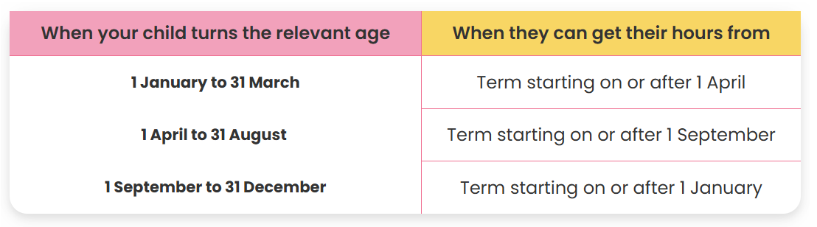
Children can access their funding from the term after they become eligible:

Stretching Your Funding
If you choose to stretch your funding over 50 weeks, the number of funded hours available depends on your child’s start date, as funding is calculated on a pro-rata basis.
Start Date | Remaining weeks in academic year | Funded hours per week
1st September 2026 | 50 Weeks | 11.4 hours
1st January 2027 | 33.2 Weeks | 10.8 hours
1st April 2027 | 21 weeks | 9.3 hours

Families who are eligible for Working Families Funding will receive double the amount shown above.
Children starting in January or April may receive fewer funded hours. Families who choose term-time only must remain on this chosen option until the start of a new term. Changes between term-time and stretched funding cannot be made during an existing term.
Please speak to the nursery manager if you would like further information.

Financial Support
Tax-Free Childcare
Tax-Free Childcare is a government scheme that helps eligible working families with the cost of childcare. For every £8 paid into a Tax-Free Childcare account, the government contributes £2, up to the relevant limit.
Families can use their Tax-Free Childcare account to help pay for eligible childcare costs. Eligibility depends on individual circumstances, so parents and carers are encouraged to check the government website for further information and to see whether they qualify.
Eligible families may receive up to:
- £2,000 per child per year
- £4,000 for children with disabilities
This can be used alongside funded childcare where eligible.
Sibling Discount
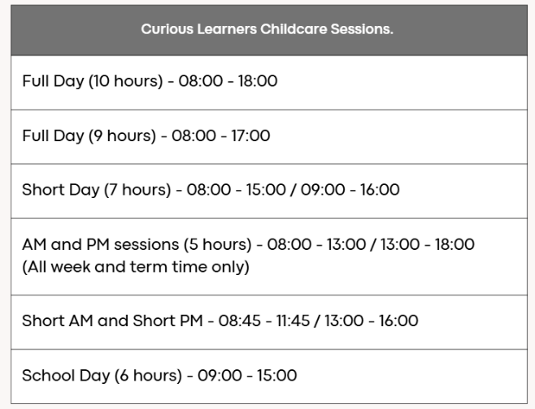
We offer a 10% sibling discount on paid sessions only.
Terms and conditions apply.
Sessions & Fees
We offer a range of childcare sessions to support family needs. Sessions are subject to availability and nursery capacity.
Fees are calculated based on your child’s booked sessions and are:
- Paid in advance
- Based on booked sessions, not attendance
- Inclusive of holidays and sickness
Fees are due by the last working day of each month for the following month’s childcare.
For further information about funding, fees, or payment options, please speak to a member of the Curious Learners Childcare Ltd team.
Curious Learners Childcare Fees: | Babies  (0-2 years) |  | Toddlers Room  (2-3 years) |  | Pre-School Room  (3-4 years)
 | All Year-Round | Time-time only | All Year-Round | Time-time only | All Year-Round | Time-time only
Hourly Rate  (Permanent Booking) | £9.00 | £10.00 | £8.50 | £9.50 | £7.50 | £8.50
Early Drop Off (7.45) | Permanent booking: £6.00 |  |  | Ad hoc booking: £8:00
Ad hoc Hourly Rate (Extra Hours / sessions) | £12.00

Deposit
Once your child has been offered a place and sessions have been agreed with the Nursery Manager, a deposit is required to secure their place. The deposit must be paid within 5 working days of your offer. If you pay the deposit and then decide not to take up the place, the deposit is non-refundable.
Funded sessions only: A £20 deposit is required. This will be deducted from your second invoice or returned within 4 weeks of your child's start date.
Funded sessions plus additional hours: A £75 deposit is required. This will be refunded when your child leaves, provided you give 4 weeks' notice and your account is fully up to date.

All Inclusive Enhanced Provision:
Government funding covers the cost of delivering the Early Years Foundation Stage (EYFS) basic provision only. It does not cover the cost of meals, consumable resources, or Famly (digital learning platforms).
For sessions that are paid for in full, these additional charges do not apply, as our hourly rate for these sessions is fully inclusive of meals, resources, and Famly (digital learning platforms.)
Meals | Digital Learning Platform | Consumables
8:00-18:00/ 08:00-17:00 - £8.50  08:00-15:00/08:00-16:00 - £7.00  09:00-15:00/09:00-16:00- £6.00  08:00-13:00 – £5.50  13:00-18:00 - £4.50  8:45-11:45 - £1.50  13:00-16:00- £0.50  Meal Times:  Breakfast: 08:00-08:45  AM Snack: 10:00  Lunch: 12:00  PM Snack: 14:30  Tea: 16:00 | £1.00 per Funded Session  Access to Famly  Daily Updates on your child  Termly progress reports  Parent Consultation  Easy Messaging Service  Keep up to date on Nursery news  Paper free enrolment process  Printed learning journey when your child leaves  In app payments and invoices | £1.50 per funded session  Wet Wipes  Nappy Sacks  Nappies (under 2’s)  Sudocrem  Suncream  Bedding (bed sheet and blanket)  Face cloths  Messy play aprons  Special events: celebration-themed crafts, food-tasting activities, baking experiences, summer picnics, Christmas activities and additional resources to support special celebration days.  Special learning experiences such as getting caterpillars for hands-on learning and Incredible Eggs, who bring eggs and an incubator for our children to see baby chicks hatch!
Opting in to our All-Inclusive Enhanced Provision

Choosing the All-Inclusive option means your child will enjoy a variety of freshly prepared, nutritious hot meals and snacks each day alongside their friends. You can simply drop your child off and go, knowing that the nursery has everything covered. There's no need to worry about packing wipes, nappy sacks (for under 2s), creams, messy play aprons, bedding, face cloths, food, or any other daily essentials—we provide it all. You'll also have full access to the Famly app, where you'll receive daily updates, photos, and information about your child's day. The app is also our main way of sharing important nursery news, special events, and reminders, so you won't miss out on key information that isn't sent by email.
Opting Out of our All-Inclusive Enhanced Provision
All-inclusive option is of course optional to our families.
Families that choose to opt out will receive:
- Access to the EYFS provision as funded by the government
- Funded hours free of charge
If you choose to opt out this will mean:
- You will need to provide your child with meals and snacks that follow our packing a healthy lunchbox policy to align with the government requirements.
- No access to our digital learning platform (main communication will be through email)
- You will need to bring your own consumables each session
- Special events, special learning experiences and celebrations will be an additional fee.
Please note that while some enhanced provisions may not be available, this will not compromise the quality of care. We remain committed to maintaining our high standards of childcare at all times.
To find out more information on any of the government programmes listed above or to check if you are eligible visit: Better Start in Life.

